**Cardiac Regeneration and Vascular Biology Conference**

**San Servolo,** 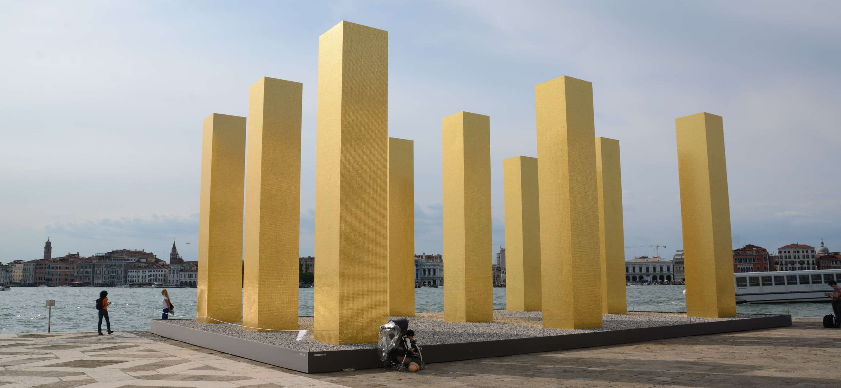

**„Cardiac Regeneration and**

**Vascular Biology“ Conference 2016**

**Convention Centre San Servolo,**

**Venice, Italy**

**June 15th – 17th 2016**

***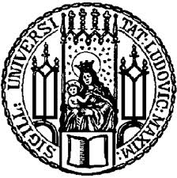*****

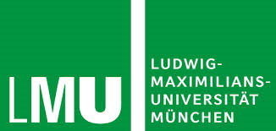

***DGK***

***Deutsche Gesellschaft für***

***Kardiologie, Herz-und***

***Kreislaufforschung e.V***

**CRC1123**

**Atherosclerosis**

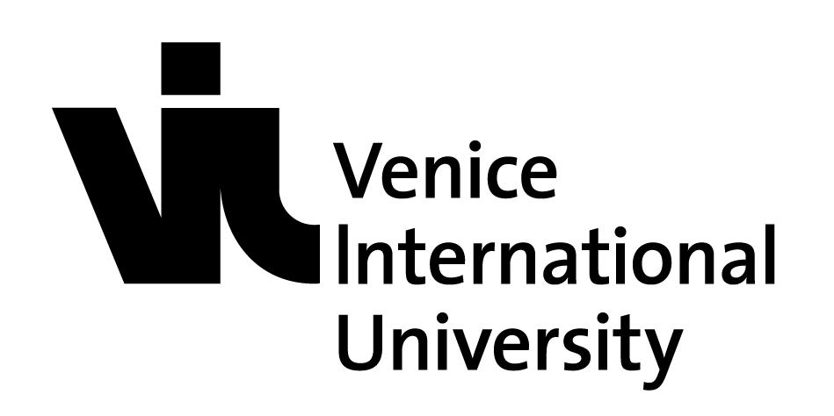

**Conference Program**

**June 15th 2016**

**12:00 Welcome address**

Christian Weber, Christian Kupatt

**Session I: Novel vascular functions**

Chairs: Ferdinand Le Noble (Karsruhe) confirmed

Christian Kupatt

12:30 – 13:00 Ferdinand Le Noble (confirmed)

Angiogenic sprouting revisited – do we get it right?

13:00 - 13:30 Seppo Ylä-Herttuala

Vascular gene therapy - status

13:30 – 14:00 Antonis Hatzopoulos (confirmed)

Arteriogenesis after myocardial infarction – a novel path to cardiac regeneration?

**14:00 – 14:15 Coffee Break**

**Session II: Epigenetics and genetic**

Chairs: Florian Limburg (Hannover) confirmed

Lutz Hein (Freiburg) confirmed

14:15 – 14:45 Gianluigi Condorelli (confirmed)

Epigenitic enzymes – novel players

14:45 – 15:15 Lutz Hein (confirmed)

Dynamics of epigenetic regulation

**Session III: Inflammatory cardiovascular remodelling (SFB)**

Chairs: Sabine Steffens (Munich) confirmed

Daniel Teupser (Munich) confirmed

15:15 – 15:45 Sabine Steffens/Horckmans (confirmed)

15:45 – 16:15 Oliver Söhnlein (confirmed)

16:15 – 16:30 Dorothea Atzler (confirmed)

**16:30 – 17:30 Coffee Break and Guided Poster walk**

**17:30 – 18:30 Keynote Lecture**

**Matthias Tschöp (Helmholtz-Munich)**

**19:00 social evening (all participants)**

**June 16th 2016**

**Session IV: SFB**

Chairs: Christian Weber (Munich)

Esther Lutgens (Munich, Amsterdam) confirmed

9:00 – 9:30 Daniel Teupser/Holdt: tba (confirmed)

9:30 – 10:00 Susanna Hofmann: tba

10:00 - 10:30 Eike Latz: tba

10:30 - 10:45Duchene: tba

10:45 - 11:15 Coffee Break

**Session V: SFB**

Chairs: Heribert Schunkert (confirmed)

Florian Limbourg (confirmed)

11:15 – 11:45 Jürgen Bernhagen: tba (confirmed)

11:45 – 12:15 Esther Lutgens: tba (confirmed)

12:15 - 12:45 Rabea Hinkel: tba (confirmed)

12:45 - 13:00 Santovito/CW: tba (confirmed)

**13:00 – 14:00 Lunch Break and Poster walk**

**Session VI: Non-coding RNAs**

Chairs: Alessandra Moretti (Munich)

Thomas Thum

14:00 – 14:30 Thomas Thum: tba (confirmed)

14:30 – 15:00 Carlos Fernandez-Hernando: tba

15:00 – 15:45 **Keynote Lecture 2:**

**Nikolaus Rajewski: tba**

**June 17th 2016**

**Session VI: Structural Heart Disease I**

Chairs: Christian Hengstenberg (confirmed)

Sabine Bleiziffer (confirmed)

9:00 – 9:30 Dario Bongiovanni (Munich) (confirmed)

BAVTAV registry: what to do in emergency

9:30 – 10:00 Gianluigi Condorelli / Derk Frank (Milano/Kiel): molecular signatures of aortic stenosis /TAVI (confirmed)

10:00 – 10:30 Philip Kahlert (Essen): neuroprotection revisited

**10:30 – 10:45 Coffee Break**

**Session VII: Structural Heart Disaese II**

Chairs: Christoph Schmitz (confirmed)

Karl-Ludwig Laugwitz

10:45 – 11:15 Stefan Baldus: MitralClip: the underestimated alternative?

11:15 -- 11:45 Isabel Bernlochner (Munich)

Novel anticoagulants: real benefit

11:45 – 12:15 Geirg Lutter (Kiel)

Transcatheter mitral valve - Status

**12:15 Closing remarks**

Christian Kupatt, Christian Weber

**Departure**